

Li-ION BATTERY FROM INDUSTRIAL WASTEWATER
INVENTOR:
FACULTY:
UNIVERSITY:
EMAIL:
CO-INVENTORS:

Product Background
- Infographic/Picture
- Text In Bullet Form
State of the Art/ Methods
- Infographic/Picture
- Flowchart (If Necessary)

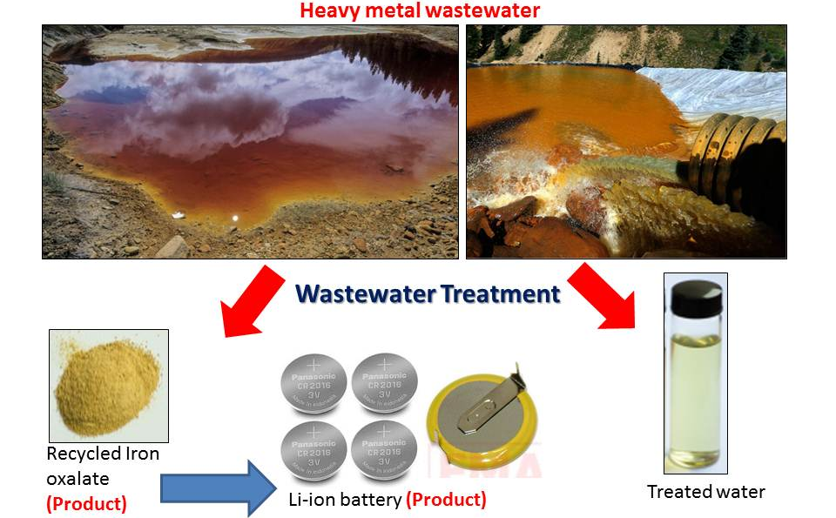
Marketability & Commercialisation
- Market Study/Market Size/Market Potential
- Technology Transfer Potential
- Social/Community Benefit
Novelty/ Originality/ Inventiveness
- Originality
- Comparison with Available Products in Market
- Technical Elements in Product
- Intellectual Property
- Inventiveness
Product Image and Product Characteristics/Results


Status of Innovation
- Product Development/Market Readiness
- TRL Level
- Status of Finished Product
- Functionality of Product
- Lab Report/Documentation
Publication
- Title, Volume, Page, Year (Indexing Status)
Benefits/Usefulness/
Applicability
- Usefulness In Solving Problems
- Applicability
- Due Diligence
- Infographic/Picture
Cost Analysis
- Cost of The Product
- Price Comparison with Available Products in Market
- Infographic/Picture
Environmental Impact/Sustainable Development Goals
- Information In Bullet Form
- Infographic
Collaboration/Industrial Partner
- Logo of Company

Achievement/Award
- Example: GOLD CITREX, 2020
- Award from Industrial (If any)

